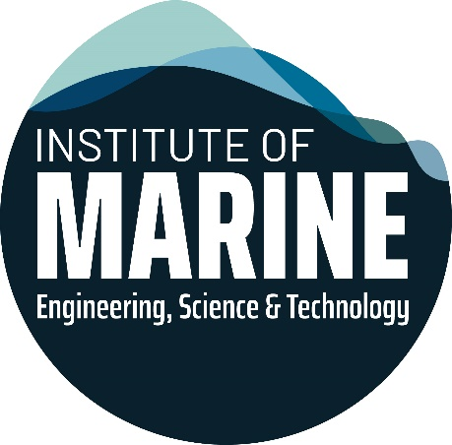

**Bil Loth OCEAN DECADE APPLICATION FORM**

**PLEASE COMPLETE THIS FORM IN BLACK INK IN BLOCK CAPITALS**

RETURN THE FOLLOWING TO: [awards@imarest.org](mailto:awards@imarest.org)

* Completed application form
* The application must include a reference from the applicant’s Project Supervisor (separate form provided), highlighting the applicant’s personal qualities, academic and project achievements.

|  |  |  |  |  |
| --- | --- | --- | --- | --- |
| **Section 1. Personal Details** | | | | |
| Surname/Family Name: | |  | Forename(s) (in full): | |
|  | |  |  | |
| Address (to be used in all correspondence): | |  | Daytime telephone number: | |
|  | |  | Country Code : |  |
|  | Area Code : |  |
|  | Telephone number : |  |
|  | |  |  | |
| Primary email Address: |  | | | |
| Secondary email Address: |  | | | |
| IMarEST Membership Category: | |  | IMarEST Membership Number: | |
|  | |  |  | |
|  | |  |  | |
| Have you ever made a previous application for this, or any other IMarEST grant? | |  |  | |

|  |  |  |  |
| --- | --- | --- | --- |
| **Section 2. CURRENT COURSE / Previous Qualifications** | | |  |
|  |  |  |  |
| Course Title: |  | University / College | Graduation Date |
|  |  |  |  |
| Course Title: |  | University / College | Graduation Date |
|  |  |  | Click here to enter text. |
| Course Title: |  | University / College | Graduation Date |
|  |  |  |  |

|  |
| --- |
| **Section 3. Summary of the Project**  Please write a short summary of the project or development project and how this relates to transformative solutions for sustainable development in the oceans using marine engineering, science and/or technology, relating this to the identified themes in the UN Decade of Ocean Science for Sustainable Development and highlighting original/innovative ideas and outcomes.  This may be an extract from the journal-style paper submitted separately. |
|  |
|  | |
|  | |

|  |
| --- |
| **Section 4. Details of any related work previously undertaken (if applicable)**  *Note: any previous work may help strengthen your application but previous work is NOT required and leaving this section blank will NOT be counted against you when your application is evaluated.* |
|  |

|  |  |  |
| --- | --- | --- |
| **Section 5A. Applicant Signature** | | |
| Applicant Signature : |  |
| Applicant Name (please print): |  |
| Date [ dd mmm yyyy ] : |  |
| **Section 5B. IMarEST-Accredited Institution Signature and Stamp** | | |
| Authorised Signature for IMarEST-accredited institution |  |
| Name (please print) : |  |
| Email Address : |  |
| Contact Telephone No. : |  |
| Date [ dd mmm yyyy ]: |  |
|  |  |
| University Stamp  **Please send your completed application to awards@imarest.org** |  |

**Application checklist:**

* Completed and signed application form, with university stamp and authorised signature
* Recommendation from applicant’s project sponsor (separate form, may be submitted separately)
* Paper, in the style of an IMarEST journal paper, exemplifying how the project scope and deliverables contribute toward the Ocean Decade themes and highlighting the original and/or innovative ideas and associated results to address the highlighted issues.